**IS 340 – Operating Systems**

**HP10 – BASH – Parameters and Variable**

7/16/2019 Developed by Kevin Wang

6/17/2020 Reviewed by Kim Nguyen

Center for Information Assurance (CIAE) @City University of Seattle (CityU)

  

**Before You Start**

* This exercise will allow students to use their existing VirtualBox VM. If you are working with a different Linux distribution, the set of shell commands may vary depending on OS version.
* Students will use their existing VirtualBox VM that they created in the module 1 exercise.
* All commands and code discussed in this exercise could various depending OS version.
* The directory path shown in screenshots may be different from yours.
* Some steps are not explained in the tutorial**.** If you are not sure what to do:
  1. Consult the resources listed below and experiment in the Ubuntu console and try to solve the problem yourself.
  2. If you cannot solve the problem after a few tries, ask a TA for help.

**Learning Outcomes**

Students will be able to:

* Understand the scope of variables
* Use the parameter expansion
* Use arrays

**Resources**

# Linux command line: bash + utilities

<https://ss64.com/bash/>

* Nano/Basics Guide

<https://wiki.gentoo.org/wiki/Nano/Basics_Guide>

**Preparation**

1. Connect to your VirtualBox VM
2. Create a directory (mkdir) IS340-Summer-2021/YOURNAME

>>> cd / IS340-Summer-2021/YOURNAME

Note: change YOURNAME to your real name

1. Create a Module10 directory under YOURNAME directory.

>>> mkdir Module10

1. Navigate to the Module10 directory.

>>> cd Module10

**Variable Scope**

1. The variable is defined in the shell will be just visible in the shell. No script that is called by the shell can see it. Test this by following the instructions below:

Type the following command to define a variable in the shell:

>>> name=Kevin

Type the following command to create a script file:

>>> nano NameTest.sh

Type the script in the file as below to print out the variable name:

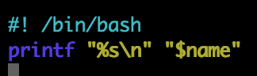

1. Hit the control + x key to quit and save the file
2. Test the script by typing the following commands:

>>> bash NameTest.sh

Note: you are supposed to see an empty output since the name variable is defined in the shell instead of in the script file (The script knows nothing about it).

1. Export the variable to the environment by typing the following commands:

>>> export name=Kevin

Note: we export the name variable to the environment.

1. Try to run the script again:

>>> bash NameTest.sh

Now our script can read the variable name we defined in the shell.

1. Use unset command to remove a variable from the environment:

>>> unset name

>>> bash NameTest.sh

You will see the empty output again

1. The variables are defined in the subshell will not be visible to the shell that called it. This is a common problem when we use the pipe functionality. Type the following command to create a file to test it:

>>> nano SubshellTest.sh

1. Type the following script in the file:

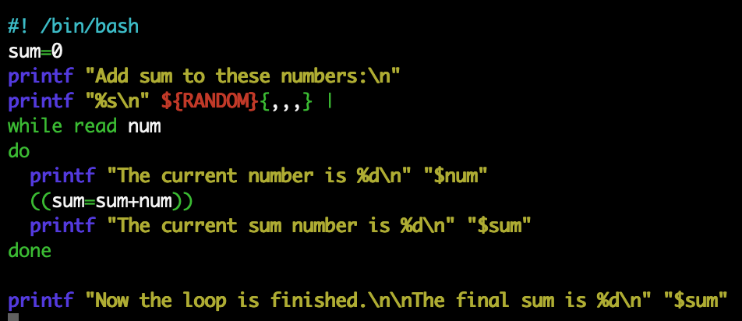

Note: we generate several random numbers and use the pipe to pass them to a while loop. The while loop adds them together and put the total value to the sum variable.

1. Hit the control + x key to quit and save
2. Type the following command to run the script:

>>> bash SubshellTest.sh

As you can see from the output, the sum variable is visible inside of the while loop but not visible after the while loop. This is because we are using the pipe operation | to run the while loop, which causes it runs in a subshell and the variable in the subshell is not visible in the caller environment.

**Parameter Expansion**

1. Copy the ShowArguments.sh file we made in the module7 by typing the follow command:

>>> cp ../Module7/ShowArguments.sh ./



1. Type the following command to test how to give a default value to a parameter:

>>> arg=

>>> bash ShowArguments.sh "${arg:-defaultArg}"



Note: we set an empty arg as the argument and call the script with a default value “defaultArg”. So, the script will take the defaultArg as the parameter value.

>>> arg=value

>>> bash ShowArguments.sh "${arg:-defaultArg}"



This time we defined a value for arg variable. So, when we run the script, it will use that value instead of the default value.

1. If we omit the colon, the script will just check whether the variable is unset. Test it by typing the following commands:

>>> arg=

>>> bash ShowArguments.sh "${arg-defaultArg}"



Even the arg is no value, the default value will not be applied since the script knows it is not unset.

1. ${var:=default} and ${var=default} can define a default value for a variable. Test it by typing the follow command:

>>> unset arg

>>> echo $((1+${arg:=100}))

1. ${var:?message} and ${var?message}will show the message when the variable is empty or unset. Test it by typing the follow command:

>>> arg=

>>> echo $((1+${arg:?EmptyVariable}))



1. ${#var} can show the length of a variable. Test it by typing the follow command:

>>> var=text

>>> echo ${#var}

1. ${var%PATTERN} will remove the shortest match from the end. Test it by typing the follow command:

>>> var=testtexttext

>>> echo ${var%text*}

1. ${var%%PATTERN} will remove the longest match from the end. Test it by typing the following command:

>>> echo ${var%%text*}

1. ${var#PATTERN} and ${var##PATTERN} will remove the shortest and longest match from the beginning. Test them by typing the follow command:

>>> var=testtesttext

>>> echo ${var#*test}

>>> echo ${var##*test}

1. ${var//PATTERN/STRING} can help to replace the match pattern with the given string. Test it by typing the follow command:

>>> var=teabct

>>> echo ${var/abc/s}

1. ${var:OFFSET:LENGTH} can return a substring of a variable. Test it by typing the following command:

>>> var=testtext

>>> echo ${var:4}

Note: the length is optional. If a length parameter is not supplied, the command will return all string from the offset position.

**Using arrays**

1. Create an array by typing the follow command:

>>> unset name

>>> name[0]=Kevin

>>> name[1]=Arthur

>>> echo ${name[0]}

>>> echo ${name[1]}

1. You also can set an array with all value in one command:

>>> unset name

>>> name=( Kevin Evan Arthur )

>>> printf “%s\n” “${name[@]}”

1. Associative Arrays allows developers to use strings as index. Test it by typing the follow commands:

>>> declare -A strArr

>>> strArr[kevin]=”Kevin’s address”

>>> strArr[evan]=”Evan’s address”

>>> echo ${strArr[kevin]}

>>> echo ${strArr[evan]}

Note: the associative arrays that use string as indexes must be declare before use.

**You can submit this completed assignment following these steps:**

1. **Push your work to GitHub** – please review module 8 HOP 8 – Github account creation.

Then, run the following commands to push your work to the GitHub repository:

>>> git add .

>>> git commit -m “Submission for Module 10”

>>> git push origin YOUR_BRANCH_NAME

>>> Then take a screenshot of your github code push and include them along with the BASH code execution when submitting your assignment in our HOP10: Bash – String Manipulation.

Note: you should change the YOUR_BRANCH_NAME to your own branch name. It should be firstname-lastname (e.g. maria-gracia).

If you cannot remember, run the command “git status” to check.

**Push your work to GitHub**

Run the following commands to push your work to the GitHub repository:

>>> git add .

>>> git commit -m “Submission for Module 7 - **YourName**”

>>> git push origin main